%reset  
%matplotlib inline  
import matplotlib.pyplot as plt  
  
#IPython is what you are using now to run the notebook  
import IPython  
print ("IPython version: %6.6s (need at least 6.1.0)" % IPython.__version__)  
  
# Numpy is a library for working with Arrays  
import numpy as np  
print ("Numpy version: %6.6s (need at least 1.13.1)" % np.__version__)  
  
# SciPy implements many different numerical algorithms  
import scipy as sp  
print ("SciPy version: %6.6s (need at least 0.19.1)" % sp.__version__)

Once deleted, variables cannot be recovered. Proceed (y/[n])? y  
  
  
IPython version: 7.8.0 (need at least 6.1.0)  
Numpy version: 1.17.2 (need at least 1.13.1)  
SciPy version: 1.3.1 (need at least 0.19.1)

# Set font sizes  
SMALL_SIZE = 10  
MEDIUM_SIZE = 12  
BIGGER_SIZE = 14  
plt.rc('font', size=SMALL_SIZE) # controls default text sizes  
plt.rc('axes', titlesize=SMALL_SIZE) # fontsize of the axes title  
plt.rc('axes', labelsize=MEDIUM_SIZE) # fontsize of the x and y labels  
plt.rc('xtick', labelsize=SMALL_SIZE) # fontsize of the tick labels  
plt.rc('ytick', labelsize=SMALL_SIZE) # fontsize of the tick labels  
plt.rc('legend', fontsize=SMALL_SIZE) # legend fontsize  
plt.rc('figure', titlesize=BIGGER_SIZE) # fontsize of the figure title

# import data  
hpf_data = np.loadtxt('./HPF.csv',delimiter=',',skiprows=1)  
lpf_data = np.loadtxt('./LPF.csv',delimiter=',',skiprows=1)  
  
# reformat data  
hpf_data = np.stack(hpf_data, axis=1)  
lpf_data = np.stack(lpf_data, axis=1)

hpf_dBs = 20*np.log10(hpf_data[1]/hpf_data[2])  
lpf_dBs = 20*np.log10(lpf_data[1]/lpf_data[2])

plt.xscale('log')  
plt.grid()  
plt.title('High Pass Filter Bode Plot',fontsize=16)  
plt.xlabel('Frequency (Hz)')  
plt.ylabel('Attenuation (dB)')  
plt.plot(hpf_data[0,1:],hpf_dBs[1:],linewidth=3)  
plt.savefig('HPF_Bode.pdf')

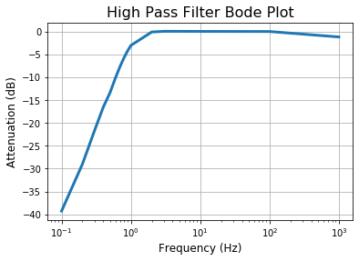

plt.xscale('log')  
plt.grid()  
plt.title('Low Pass Filter Bode Plot',fontsize=16)  
plt.xlabel('Frequency (Hz)')  
plt.ylabel('Attenuation (dB)')  
plt.plot(lpf_data[0,1:],lpf_dBs[1:],linewidth=3)  
plt.savefig('LPF_Bode.pdf')

